**CO3 PYTHON**

**MATH MODULE**

import math

print("the value of pi is",math.pi)

import math as m

print("the value of pi is",m.pi)

from math import pi,sqrt

print("the value of pi is ",pi)

print("the square root of 4 is ",sqrt(4))

print(math.cos(90))

print(math.sin(3))

print(math.tan(0))

OUTPUT:

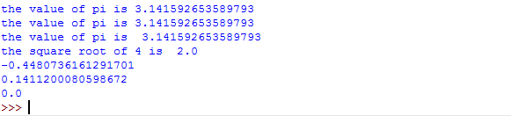

**TIME MODULE**

import time

print("current time in sec:",time.time())

print("current time:",time.ctime())

print("current time after 30 sec:",time.ctime(time.time()+30))

t=time.localtime()

print("time:",t)

print("current Year:",t.tm_year)

print("current Month:",t.tm_mon)

print("current Day:",t.tm_mday)

print("current Hour:",t.tm_hour)

print("current week:",t.tm_wday)

print("Day of Year:",t.tm_yday)

print("formatted time:",time.strftime("%d /%m /%y %H:%M:%S %Y ",t))

print("formatted time:",time.strftime("%c %H:%M:%S %Y ",t))

print("......................................")

OUTPUT:

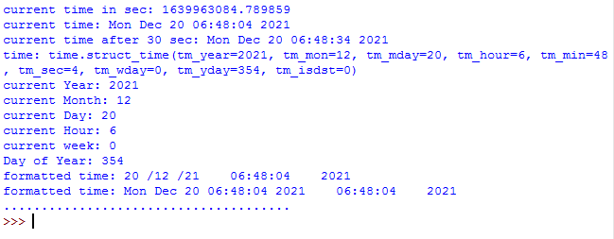

**CALENDER MODULE**

import calendar

mm = int(input("Enter month: "))

yy = int(input("Enter year: "))

print(calendar.month(yy,mm))

print(calendar.calendar(2015))

OUTPUT:

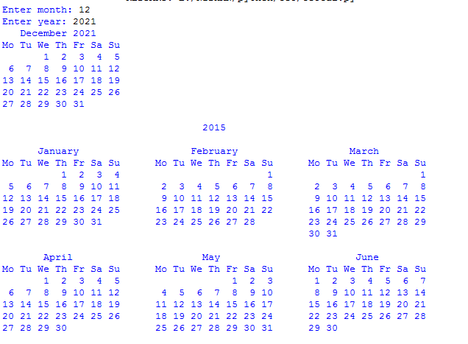

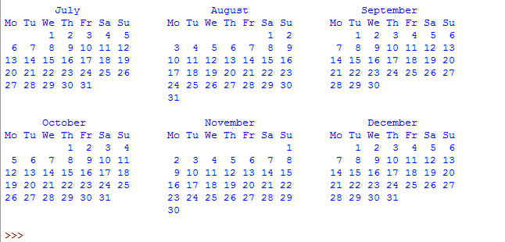

**DATE & TIME MODULE**

import datetime

t=datetime.time(22,56,44)

print(t)

print("Hour:",t.hour)

print("Minute:",t.minute)

print("Second:",t.second)

print("microsecond:",t.microsecond)

print(".........,,,...........")

d=datetime.date.today()

print(d)

print("Year:",d.year)

print("Month:",d.month)

print("Day:",d.day)

print("timeandcalmodule.py")

d1=datetime.date.today()

print(d1)

td=datetime.timedelta(days=2)

print(td)

d2=d1+td

print(d2)

print("d2-d1=",d2-d1)

print("d2>d1=",d2>d1)

print(".........,,,,,..........")

d1=datetime.date.today()

t1=datetime.time(12,55,0)

dt=datetime.datetime.combine(d1,t1)

print('dt:',dt)

OUTPUT:

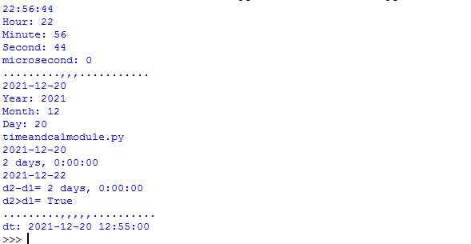

**RANDOM Module**

import random

list1 = [1, 2, 3, 4, 5, 6]

print(random.choice(list1))

print("*************")

import random

random.seed(5)

print(random.random())

print(random.random())

print("***********")

import random

r1 = random.randint(5, 15)

print("Random number between 5 and 15 is % s" % (r1))

r2 = random.randint(-10, -2)

print("Random number between -10 and -2 is % d" % (r2))

print("**************")

import random

list1 = [1, 2, 3, 4, 5, 6]

print(random.choice(list1))

string = "geeks"

print(random.choice(string))

tuple1 = (1, 2, 3, 4, 5)

print(random.choice(tuple1))

OUTPUT:

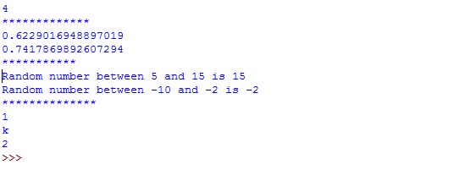

**STATISTICS Module**

import statistics

list1 = [5,2,5,6,1,2,6,7,2,6,3,5,5]

x = statistics.mean(list1)

print(x)

y = statistics.median(list1)

print(y)

z = statistics.mode(list1)

print(z)

a = statistics.stdev(list1)

print(a)

b = statistics.variance(list1)

print(b)

OUTPUT:

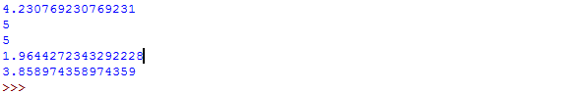

**Program 2.**

**PACKAGE**

*Co3 graphicspack.py*

from graphics import rectangle

from graphics import circle

rectangle.arear(int(input("enter length of rectangle")),int(input("enter breadth of rectangle")))

circle.areac(int(input("enter radius of circle")))

*rectangle.py*

def arear(l,b):

print("area of rectangle is ",l*b)

print("perimeter of rectangle is",2*(l+b))

*circle.py*

def areac(r):

print("area of circle is",3.14*r*r)

print("perimeter of circle is",2*3.14*r)

OUTPUT:

